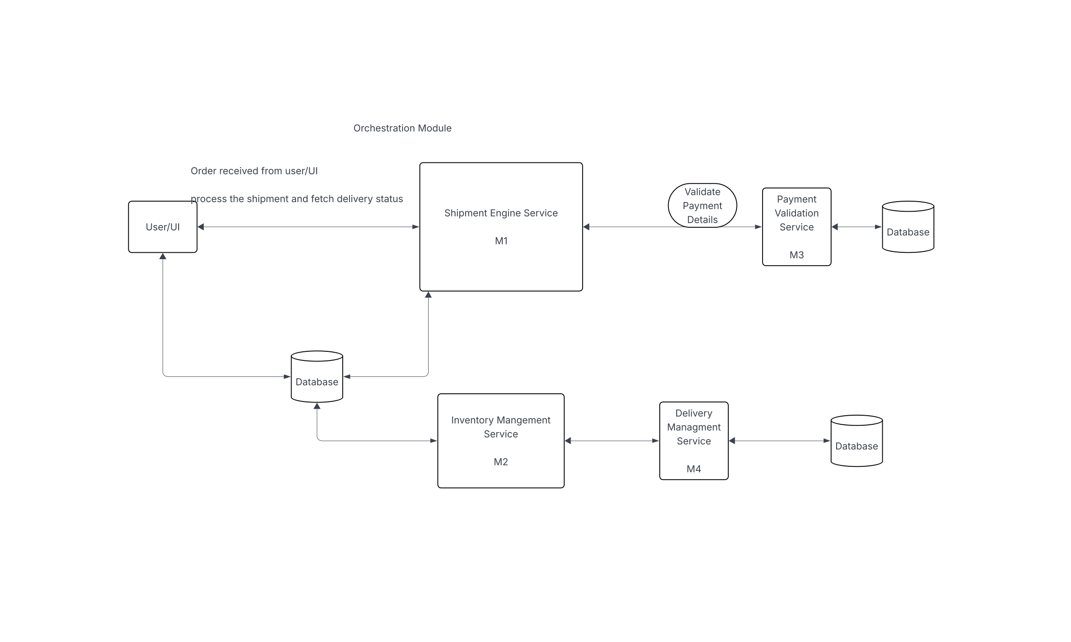

Automated Shipment Service

- Develop 4 microservices using Spring Boot 2.x, 3.x version (https://start.spring.io/)
  - Implement spring security using form login to login to the app 1 (Microservice 1)
    - Password can be hardcoded in the app or store in the DB -> Optional

“stage”: ”PAYMENT_VALIDATION/INVENTORY_VALIDATION/DELIVERY_IN_PROGRESS”,
“status”: “DRAFT/PROCESSING/COMPLETED/FAILED/ERROR
b. Use of Log4J, @Sl4j
i. Level of logging should be defined properly.
c. Unit test cases should properly have code coverage on lines of code and
methods.
- Libraries – Mockito, Junit 5
    - Annotations - @spy, @Mock, @ArgumentCaptor
    - Assertions – use of verify, atLeast, null/not null, true false on the method response.

- M 1 should receive product order via API as a JSON request.
  - Request body/Payload: JSON (Create an DTO (Data transfer Object)
    - E.g.
      - {
“orderId”: “test123” (unique)
“products”: [
{
“productName”: ”testname2”,
“productId”: “testId1”
},
{
“productName”: ”testname2”,
“productId”: “testId2”
}
],
“payment_id”: “z2343252”

  - Insert the record in shipment tracker table,
    - stage: REQUEST
    - status: RECEIVED
    - attempts: 0
- Develop a scheduler Job (Request Process Job) – (RequestProcessJobService – java class name) to run every 2 seconds and poll shipment tracker table records with Stage Request and status received. @Scheduled configuration
  - Job properties should reside in application properties and be configurable.
  - Spring JPA query to poll the database with given stage and status
  - Once record is found, call the payment service rest api, (request param should be product Id) – https://abc:8080/payment_service?paymentId=123)
    - Use RestTemplate (postForObject, exchange)
    - Response object:
{
“result”: “success/failed”,
“result_msg”: “system issues”
}
  - REST API Response.
    - Response received, deserialize to the expected response object in c – ii.
    - If success, update the stage to – PAYMENT_VALDATION and status – COMPLETED,
    - Else/if result is failed, update the stage to PAYMENT_VALIDATION and status – FAILED and PROCESS_MSG.
  - Handle the error is any (try – catch – if any issues – increase the attempts in the record.
    - Catch block should increase the attempts (attempts + 1), save the record.
    - Also, check if attempts is 10 and if it is update the status as ERROR.

SHIPMENT_TRACKER

ORDER_ID(PK) | PRODUCT_NAME | PRODUCT_ID (PK) | PAYMENT_ID | SHIPMENT_ID | SHIPMENT_STATUS | STAGE | STATUS | ATTEMPTS | PROCESS_MSG | CREATED_DATE | CREATED_BY | UPDATED_DATE | UPFATED_BY
VARCHAR2(200) |  |  |  |  |  |  |  |  | VARCHAR2 (4000)

- Payment Validation Service (M2):
a. develop an api to check the db table payment_merchent_audit, for the paymentId.
  - Table should contain paymentId, and status – ACTIVE/INACTIVE
    - Response object:
{
“result”: “success/failed”, - active?sucess: failed with error msg (can be Invalid Payment Id)
“result_msg”: “system issues”
}
    - Exception Handling: same with M1 service.
- Inventory Management Service (M3) : Develop a scheduler Job (Request Process Job) – (RequestProcessJobService – java class name) to run every 2 seconds and poll shipment tracker table records with Stage PAYMENT_VALIDATION and status COMPLETED.
  - Job properties should reside in application properties and be configurable.
  - Spring JPA query to poll the database with given stage and status
  - Once record is found, check inventory is present,
a. check if the product Id exists in Inventory_Audit table
- productId | - product_name | - is_available
 |  | - Yes/No

  - call the delivery management service (M4) rest api,
    - json request:
{
“orderId”: “afda”,
“products”: [
{
“productId”: “1eew”,
“includesBattery”: “false”,
“productDimensions”: “”
},
{
“productId”: “1eeqwrqww”,
“includesBattery”: “false”,
“productDimensions”: “”
},
],
“shippingSpeed”: “”
}
  - REST API Response.
    - Json response:
{
“result”: “success”,
“shipmentId: “123144”,
“result_msg”: “”
}
    - If Success, Update record stage to SHIPMENT status to IN_PROGRESS and update Shipment ID.

